DATA VISUALIZATION IN SNOWFLAKE

Let’s create a table ‘stores’
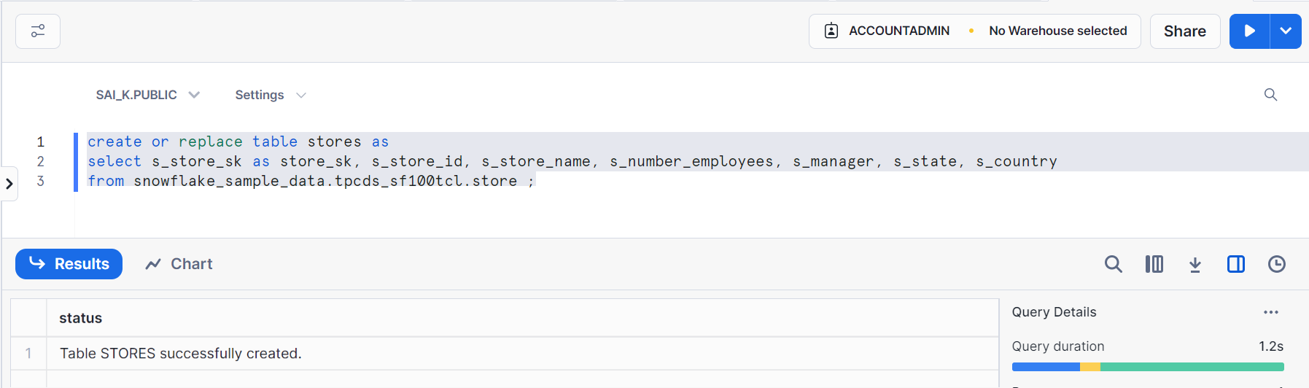
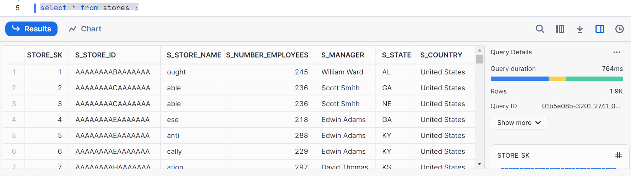
Create another table with some filters as shown
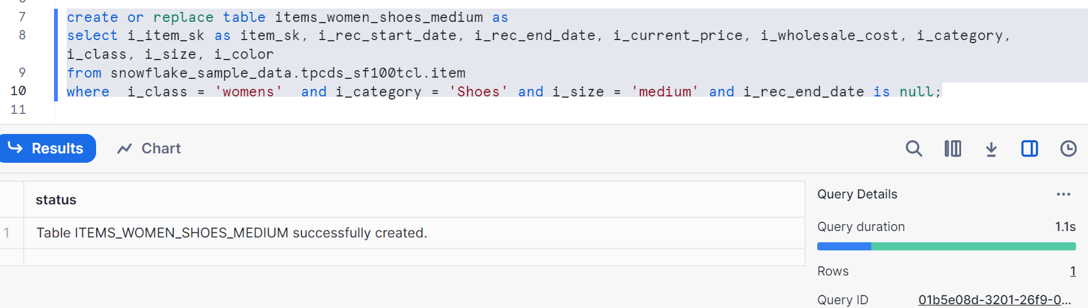
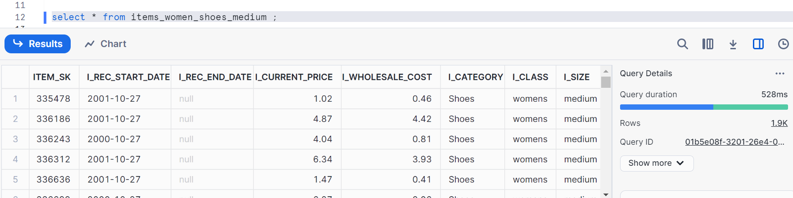
Create another table with filters
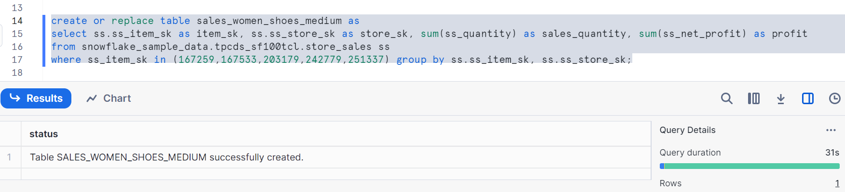
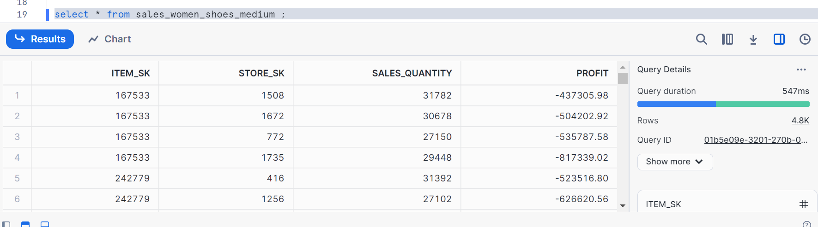

So, we had created three tables i.e. stores, items_women_shoes_medium, sales_women_shoes_medium

Let’s set up the data to visualize
Click on chart, chart type as Line as shown once you run the query
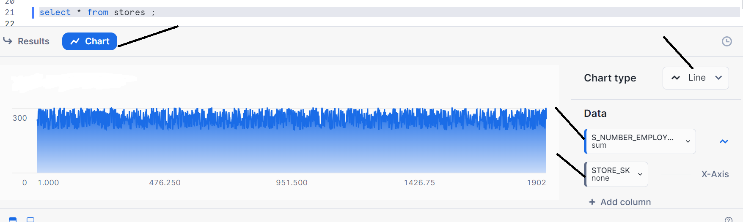
We can change Y axis to any aggregation as shown
We changed S_NUMBER_EMPLOYEEs from sum to average for demo
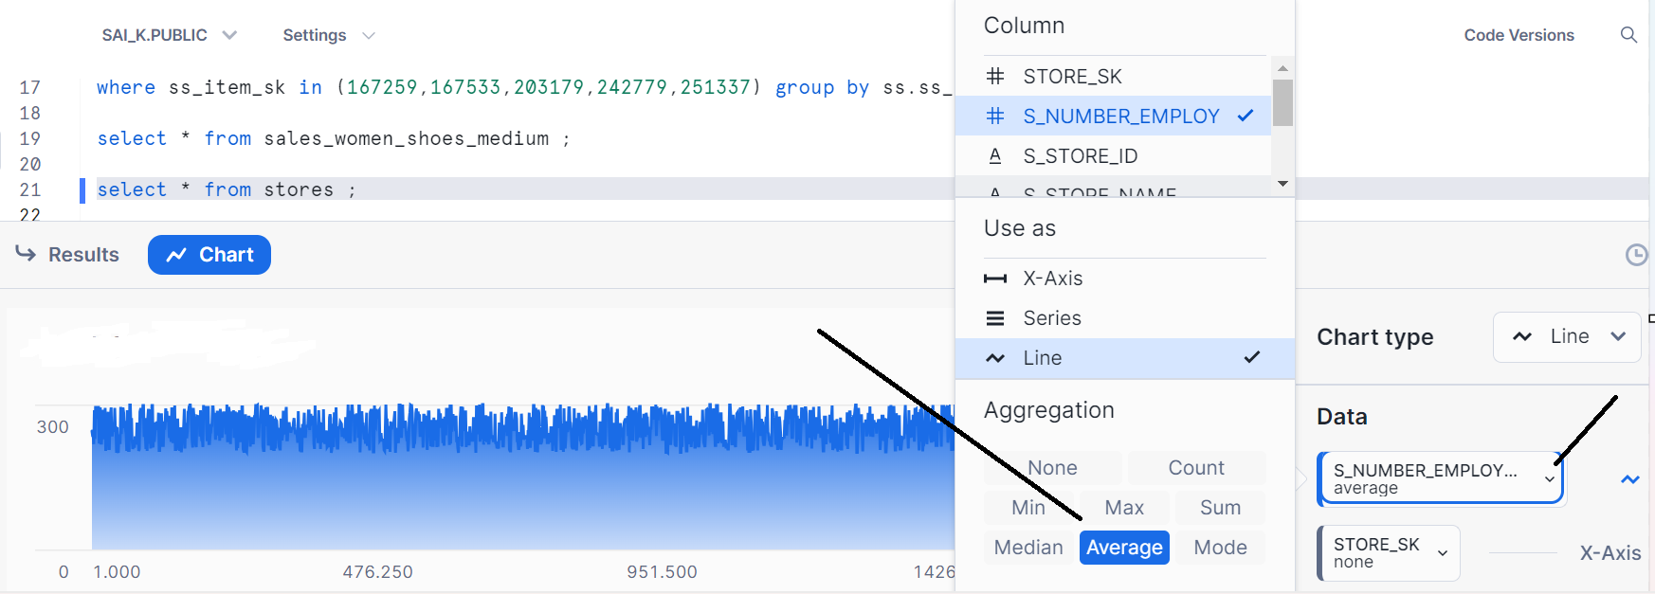
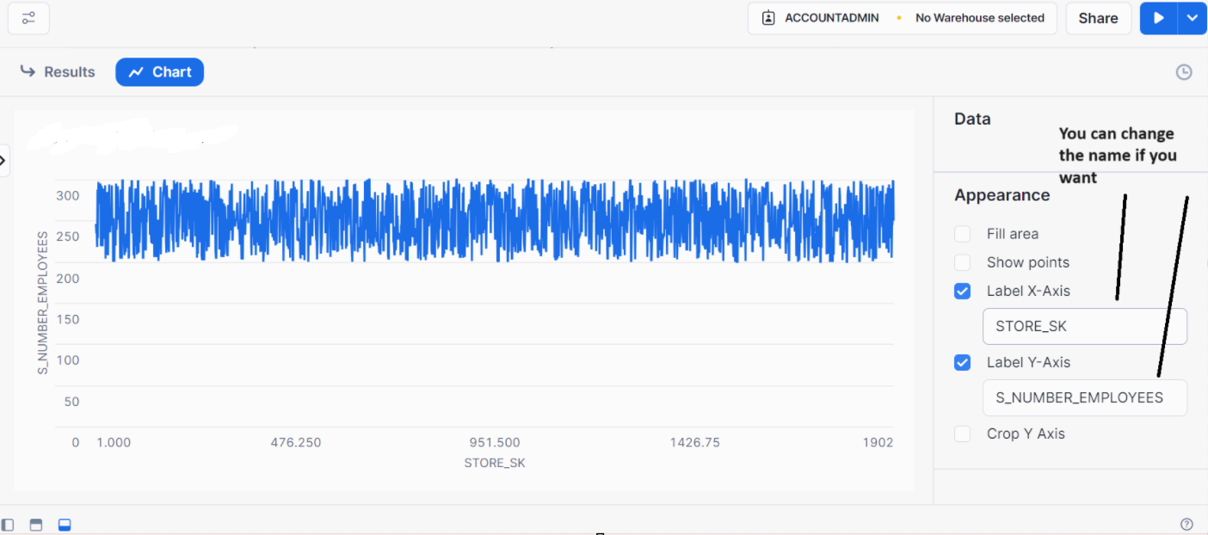
Let’s see the bar graph with the same query
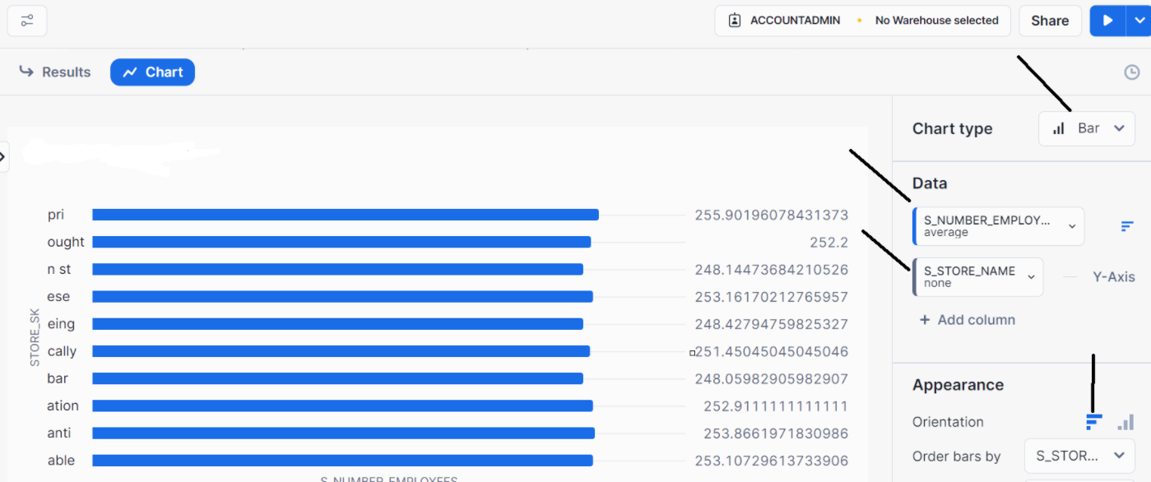
Validate with a query for above chart
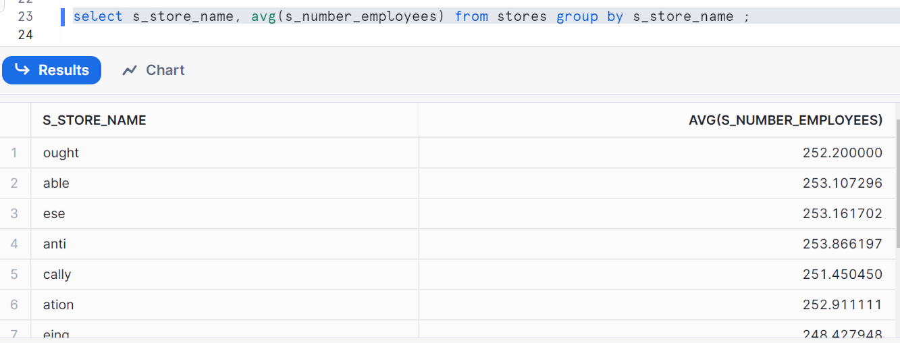
Now, let’s plot differently with different query
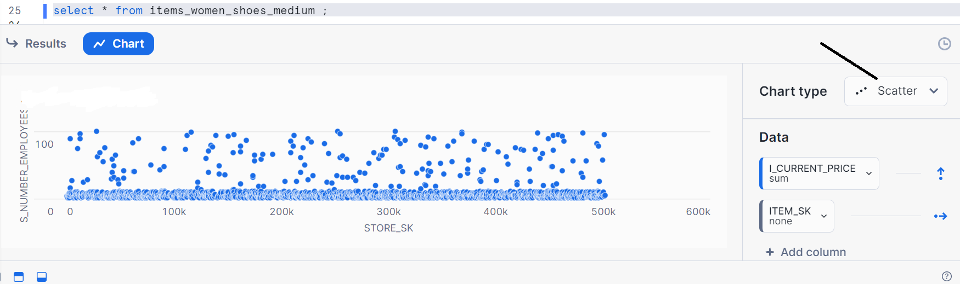

Changed label axis i.e. naming
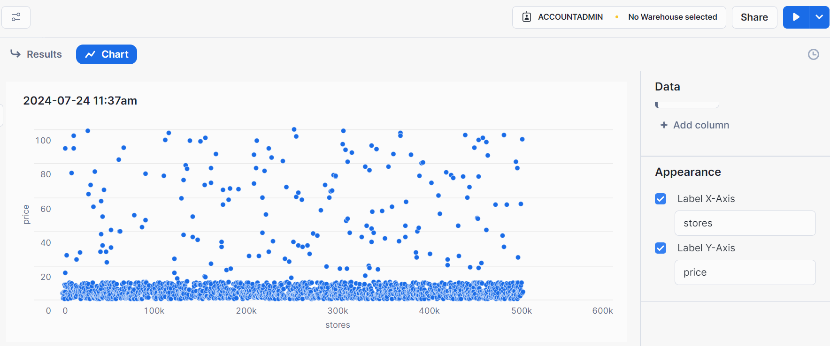
Let’s see heat map with same query
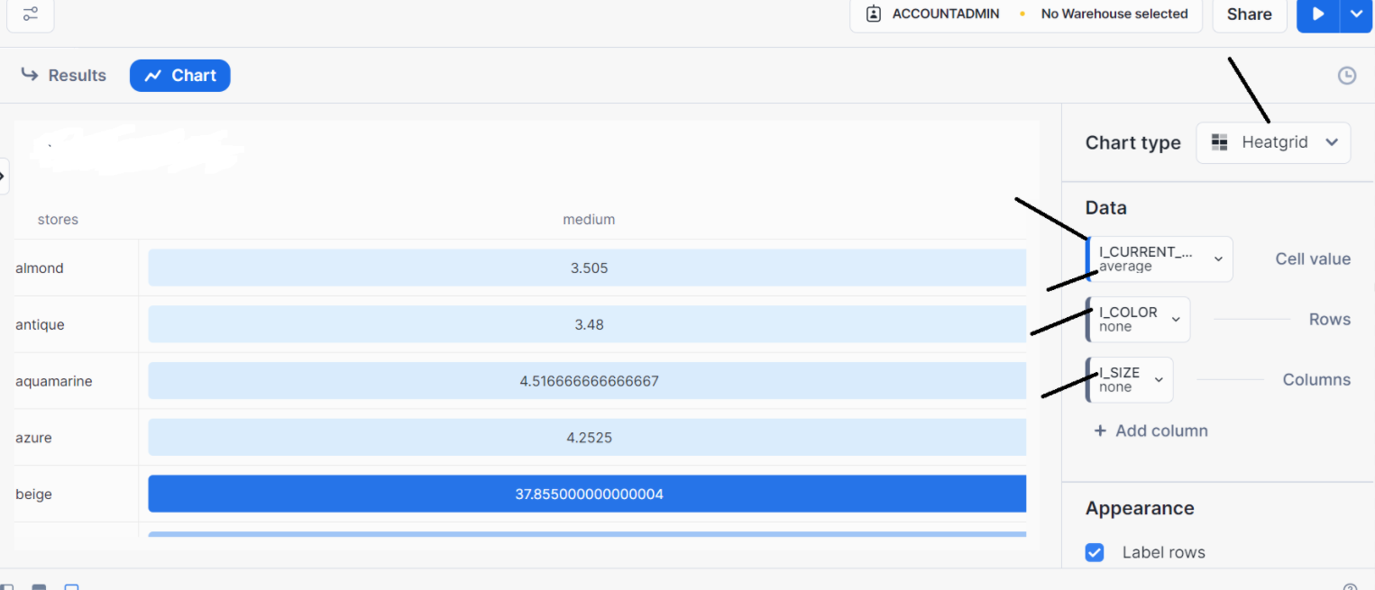
Higher the value, darker is the color
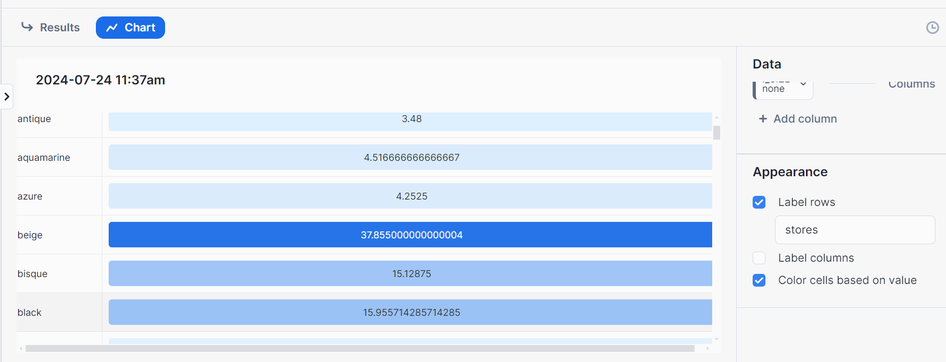
Let’s see scorecard
Wanted to see average price of medium shoes for women
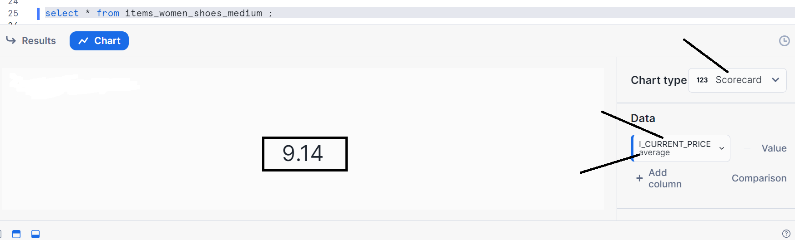
Average wholesale cost
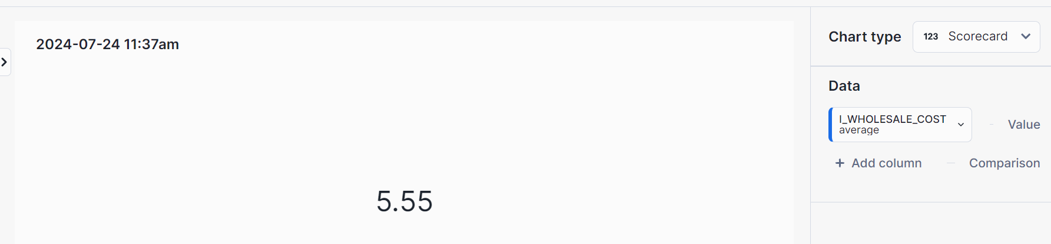

You can compare with other column value
Click add column
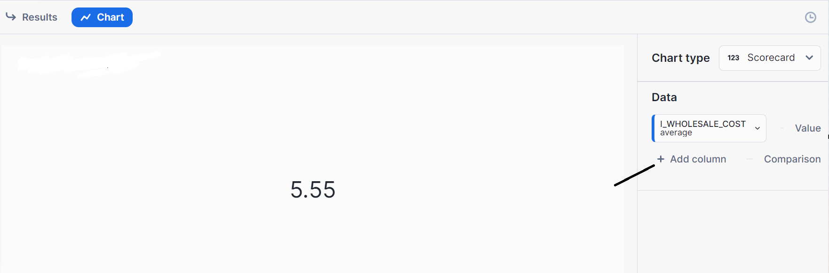
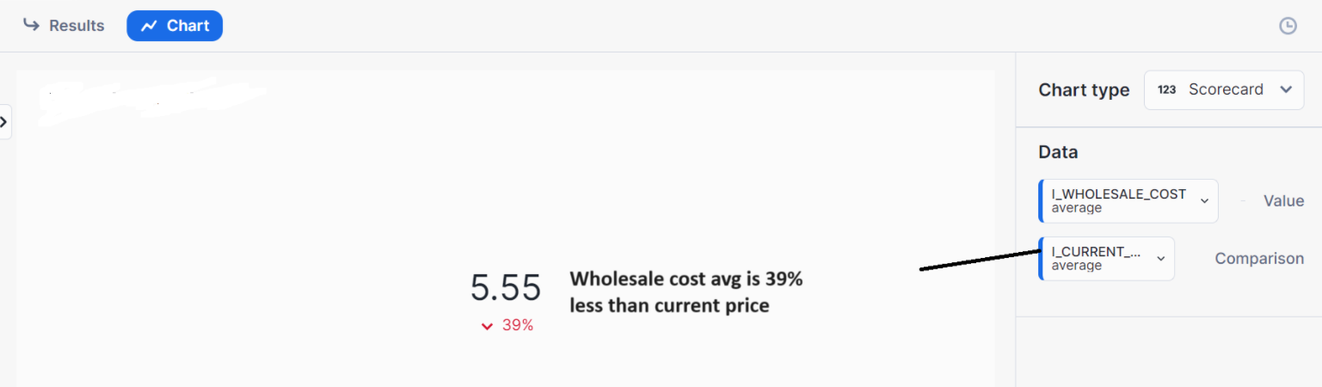
Now, let’s plot a bar graph with two values with a query as shown
Select item_sk, sum (sales_quantity), sum (profit) from sales_women_shoes_medium group by item_sk;
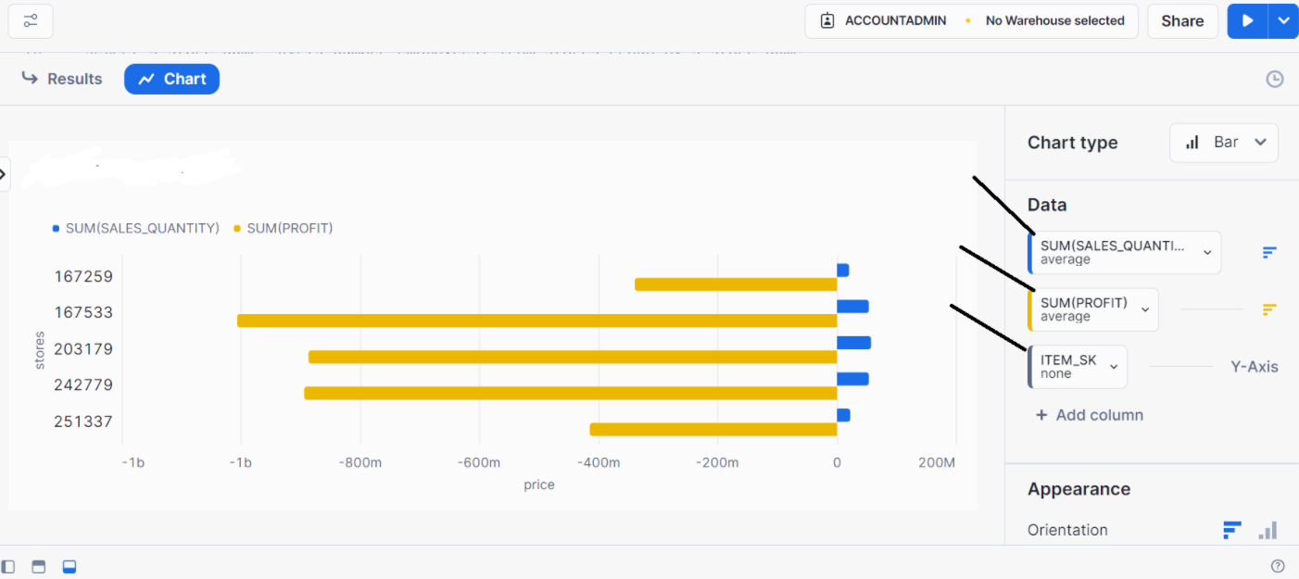
Change the orientation as you want
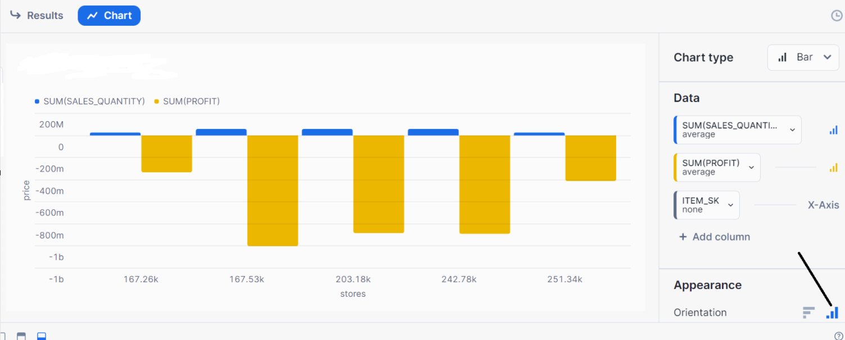
You can change the appearance as you want
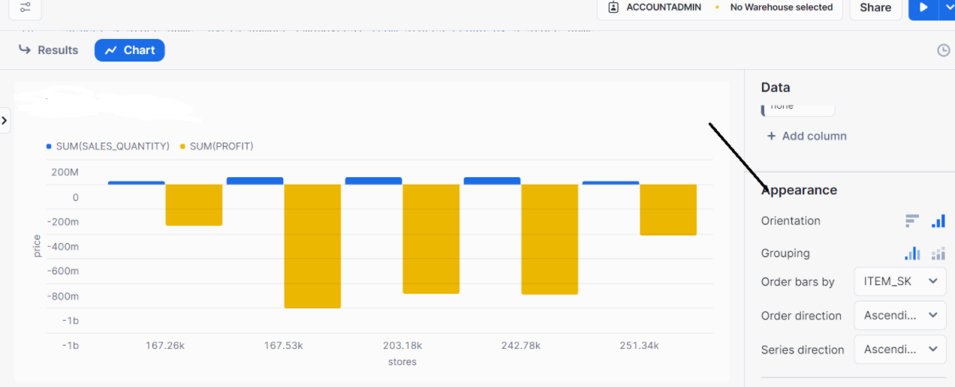

Thanks

